SCIENCE LABORATORY EQUIPMENT

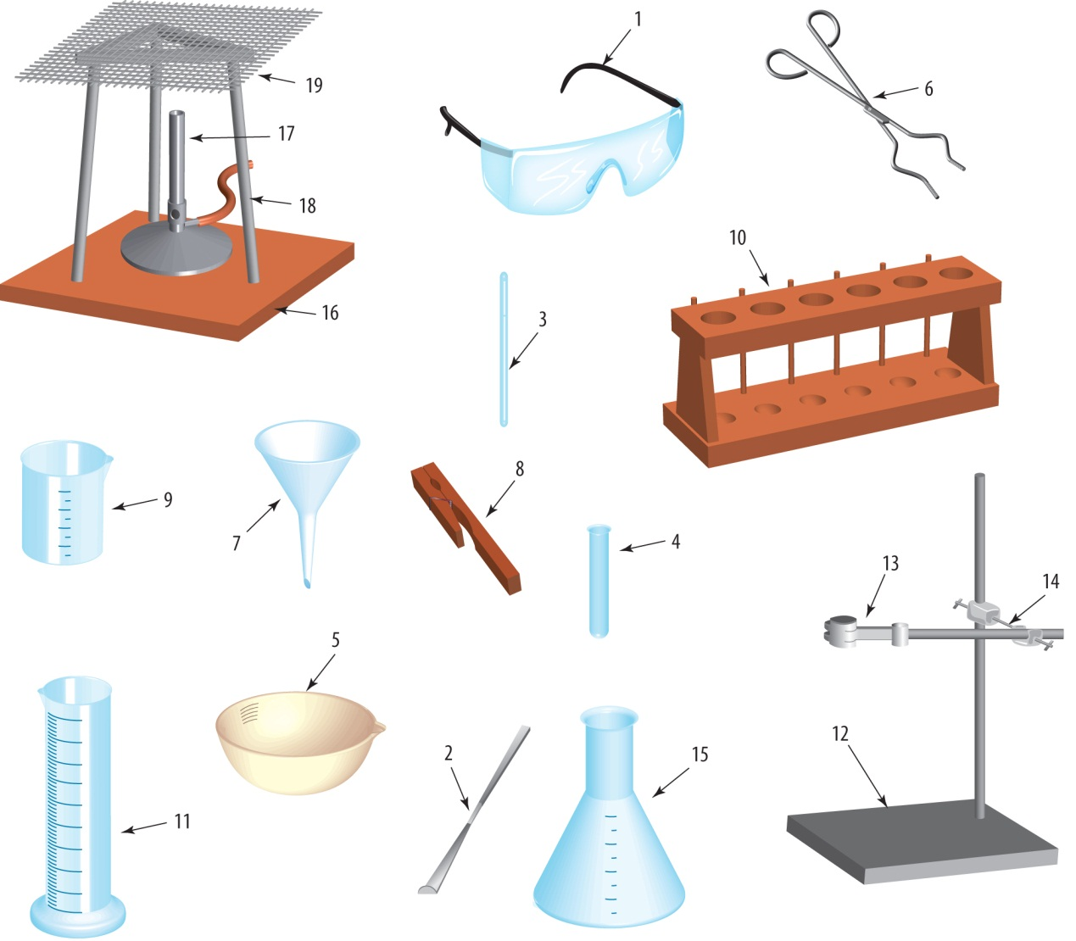

goggles beaker test tube holder conical flask Bunsen burner tripod spatula

filter funnel gauze mat heat proof mat test tube rack measuring cylinder

retort stand evaporating basin clamp tongs boss head test tube stirring rod

Use words from the box below to complete the table to name the equipment.

Number of piece of equipment | Name of piece of equipment
1
2
3
4
5
6
7
8
9
10
11
12
13
14
15
16
17
18
19

